Iconography – style guide
What is an icon?
An icon is a graphical representation of an application that, when clicked on, will trigger a particular action. Generally, icons represent objects, tools, actions or desired results.

Icon usage
The overuse of icons can increase cognitive load for users. The more icons you use, the less attention they draw. Consider whether adding an icon to the interface increases usability and clarity. Use them when space requires it, to communicate status, or to help differentiate object.
example
Design Principles
Shapes are bold and geometric. Symmetry and consistency of shapes give the icons a unique quality, while keeping them simple and bold. Icons can be used in the web, Android, iOS and WP applications. The design is inspired by <link> Goggle Material Design <link>.

Types of icons
- Custom Icons:
Custom icons are the visual expression of the brand’s products, services, and tools. Simple, bold, and friendly, they communicate the core idea and intent of a product. While each custom icon is visually distinct, all custom icons for a given brand are unified through concept and execution.
Examples:
Find a doctor, Umbrella (benefits), ID card

- System Icons:
A system icon, or UI icon, symbolizes a command, file, device, or directory. System icons are also used to represent common actions.
Examples:
Edit, Delete, Search
<Link>icon library<link>
Grid system
The icon grid has been developed to facilitate consistency and establish a clear set of rules for the positioning of graphic elements. This standardization results in a flexible but coherent system.
Grid:
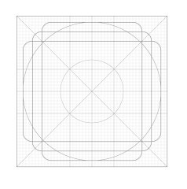
Keyline:
Square and circle
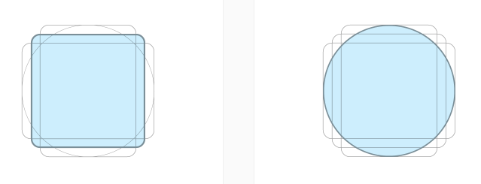
Verticle and horizontal rectangle
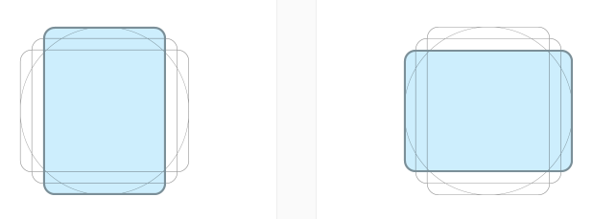

Sizing
Nick - let’s talk about it.
Consider for Web, mobile and print

Colors
Icon colors for web, mobile and print
Inverse colors if any

Icon states
Active state - opacity
Inactive state – opacity
Default

Icons used with UI components
- Examples of multiple panel components shown with the icon and context
With Do and Don’t
- Examples of just icon and a link in the panel (something like on dashboard)
With Do and Don’t
- Examples of icons used on buttons
With Do and Don’t
- Example of system icon without context
With Do and Don’t
- Example of standalone icons (Mobile app’s utility bar or for some future state. For example Home, hamburger with border/button style, a bell for notification)
With Do and Don’t
- Example of in context icon. (info popover, alert box icon etc.)
With Do and Don’t

Icon library:
Find the icons in use. You may use the icon that is already in use from the icon library. If you need an icon that is not part of the library yet please contact Ankit Shah <email>
<Icon library link>
Note: We should have a link to another page (icon library). We should create another page for the library and have 2 sections on the page, custom and system icons.
Library page layout:
Have a search bar on the top of the page.
Divide icons into 2 sections. Custom and system.
Add all the icons we designed with the name and if possible Unicode.
Later-let’s talk about it more in detail. What else we need there.

Design approach
Icons should have consistent look and feel across. They must convey the right message to our customers either in context or without context. Icon design has been inspired by industry design leaders such as Google material design<link-https://www.google.com/design/spec/style/icons.html#>, John Hicks<link-http://iconhandbook.co.uk/> and IBM design language<link-https://www.ibm.com/design/language/framework/visual/iconography>. Most of the icons we used are leveraged from <link>Google Material design library<link-https://design.google.com/icons/>. We took this approach so we don’t break any conventions and using one source gives us enough stability for the consistent look and feel.
The process of an icon design
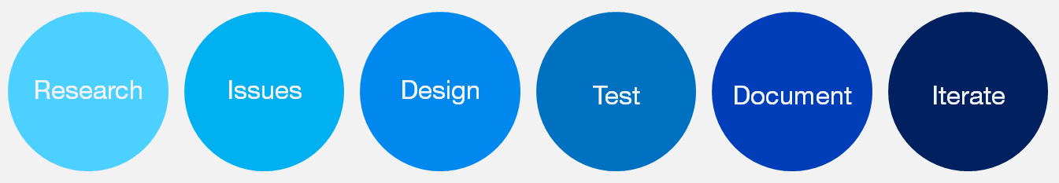

Usability test of icons
Most of the icons from the library <link> have been gone through usability test. We have tested 4 attributes for each icons at-least with 5 or more users.
Attributes we tested are
- Findability: Can users find the icon on the page?
- Recognition: Do users understand what the icon represents?
- Information scent: Can users correctly guess what will happen once they interact with the icon?
- Attractiveness: Is the icon aesthetically pleasing?
Web: For more detail please contact <email>Ankit Shah, UX Designer <email> or <email>Irish Maling <email>
Print: contact Dominic D.

